**BRIGHTON & HOVE GREEN SPACES  FORUM NEWSLETTER**

**March 2018**



**Membership update**

You are receiving this newsletter because you are one of 77 groups or 10 individuals who have expressed an interest and have

registered with BHGSF.

67 groups are featured on the website which is still evolving with a view to making it easier for groups to highlight events.

[<bhgreenspaceforum.org.uk>](http://bhgreenspaceforum.org.uk)

Facebook. <https://www.facebook.com/bhgsforum/>

Twitter. @bhgsforum

**Heritage Lottery Fund**



The HLF is closing its Parks for People funding programme.  Councils are being forced into a position to sell parks for development to fund future maintenance. Many councils have seen on average a budget fall of 40% leading to plans to transfer parks to a charitable trust. Our council is working towards setting up a Parks Foundation.

  See The Parks Alliance petition below



**The Parks Alliance** set up an on-line petition through 38 degrees in response to the Heritage Lottery Fund abandoning their Parks for People programme. They will be handing the petition in to HLF before **the consultation closes on the 22nd March.**

At the time of writing it has hit 178,880 signatures. **Please sign this important petition**

<https://you.38degrees.org.uk/petitions/protect-heritage-lottery-funding-for-parks>[.](http://.)

**Community Works**



 Denise Taylor Chair Brighton & Hove City in Bloom is the outgoing greenspace representative for Community Works and has handed the role to Melanie Davis Chair of FO St.Ann’s Well Garden.

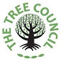

**Create a Tree Trail**  
The Tree Council has teamed up with TiCL Media to encourage visitors to parks to explore and learn about the trees in a park or towns without the need for printed map or signage.

You can create a #TreeTrail yourself here.

<https://www.treecouncil.org.uk/Press-News/Make-a-Tree-Trail>

Friends of St Ann’s Well Gardens already have a TiCL Media Tree trail up and running, should people want to check out a working one.



**South & South East in Bloom**

Thank you to all groups who have entered this years competitions We are waiting to hear what the total figure across the city is including the council’s own entries, but we do know it will be a record number Please save the date of **25th April at 6pm** when we will be holding a workshop to help all entrants improve on their marks when the judges arrive. Venue to be arranged.

.

**Easter in our parks and green spaces**

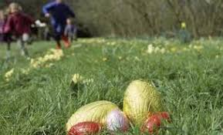

If you have an event please let us know and we will Tweet it and add it to our website on your behalf. <[bhgsforum@gmail.com](mailto:bhgsforum@gmail.com)>

**Closure of Stanmer Nurseries**

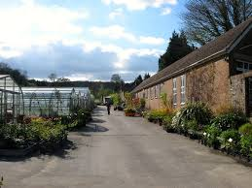

The nursery is closing to make way for the restoration of the Walled Garden. This has been made possible due to the success of a bid by Brighton & Hove City Council to the Heritage Lottery Fund - part of the[Stanmer Park Restoration Project](http://goog_573191637/)[.](http://./)  <https://www.brighton-hove.gov.uk/content/leisure-and-libraries/parks-and-green-spaces/stanmer-park-restoration-project>. This closure will include the wildflower cultivation unit.

Following the expression of concern from some members about this closure, the Forum obtained the following statement from the Council - Quote *“City Parks are working with other organisation partners to try to identify the best option for how local wild flowers can be produced in the future. It will no longer be done directly by the council itself, but we are concerned to ensure that there is both a space and other support available for it to still happen.*

**Brighton & Hove Way –** The Mayor’s Charity Walk 2018

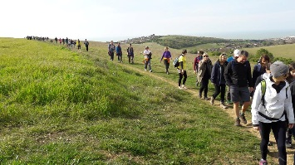 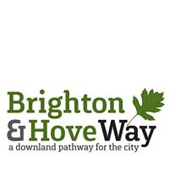

Hundreds of people are expected to join the sponsored anniversary walk**on the 28th April** to celebrate the new pathway around the city. The Brighton and Hove Way was established to create a permanent, recognised and accessible trail to celebrate the city downland. Register for all, or part of, the 27k walk. <https://app.etapestry.com/onlineforms/RISE_1/boundarywalk.html> .The charity walk will support the Mayor’s chosen charities with support from City Parks and the Brighton and Hove Way Association.

You can become a volunteer Path Warden to help keep an eye on sections of the trail; checking a designated part every three months.   <http://www.brightonandhoveway.org.uk/>

On **April 14th City Parks Tidy Up Team** is arranging to litter-pick the Woodingdean – Falmer Link Route of the Brighton & Hove Way meeting at Bexhill Road car park at 10 till 12pm.<https://www.brighton-hove.gov.uk/content/leisure-and-libraries/parks-and-green-spaces/tidy-team-volunteer-litter-pickers>

**Living Coast**

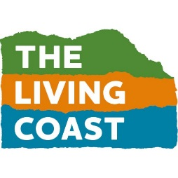

Follow the link here to find local eco-events through The Living Coast including Healthwalks, Bee-keeping and  clean-ups. You can feature your eco-events on this site.

<https://www.thelivingcoast.org.uk/whats-on>

**Communities Fund Grant**

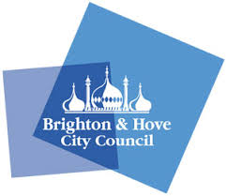         

Brighton and Hove Green Spaces Forum have applied for a B&H Communities Fund grant. If successful this will help us deliver some tangible support for member groups.

**Citizen Scientists**



A fifth of the world's food is grown in urban areas, but very little is known about how it is produced. If you grow your own food, scientists at the University of Sussex are looking for growers in Brighton & Hove to volunteer to become ***'****citizen scientists'* to help learn more about which insects are pollinating the food you grow.

Sign up to volunteer with Team PollinATE [https://www.teampollinate.co.uk](https://www.teampollinate.co.uk/) .

With every good wish from The Team.



**Website -**[**http://bhgreenspaceforum.org.uk**](http://bhgreenspaceforum.org.uk)

**Twitter - @bhgsforum**

**Facebook -**[**https://www.facebook.com/bhgsforum/**](https://www.facebook.com/bhgsforum/)