**BRIGHTON & HOVE GREEN SPACES FORUM NEWSLETTER**

**July 2018**

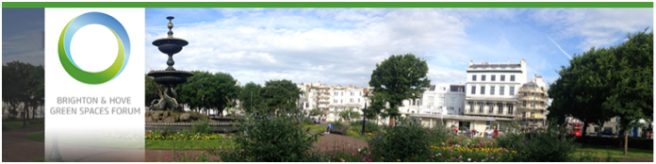

Brighton and Hove Green Spaces Forum (BHGSF) is a volunteer organisation providing an independent voice and communication hub for volunteer groups working with Brighton & Hove’s parks and open spaces.

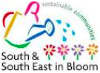

**South & South East in Bloom**

BHGSF held a workshop for entrants to the S&SEIB competitions on 25th April to highlight judging criteria to maximise scores. 24 people attended the session held at Portslade Town Hall. Many thanks to Ranger Paul Gorringe for facilitating the meeting. There are a total of

28 entries this year from the city with judging taking place during June and July. Regional prize giving is on 14th September at the Amex. There will also be a Brighton & Hove celebration held by us for local groups on 15th October. See below.

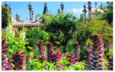

**Royal Pavilion Garden Survey**

This survey closed on 29 June to comment on all aspects of the garden from planting, seating, the boundary and walkways to attractions and events; as well as how to tackle anti-social behaviour make people more aware of its heritage.

Thank you to all those who  completed the survey and passed the on to their own databases.

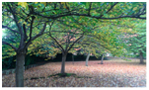

**Charter for Parks launched on 21st June**

The following coalition of countryside groups and environmentalists are calling on the government to protect the UK’s parks and green spaces which are at “crisis point”

National Federation of Parks and Green Spaces. The Parks Alliance . The Conservation Volunteers · Friends of the Earth ·Llais y Goedwig · Unison · The Gardens Trust· Greenspace Scotland ·  Keep Britain Tidy ·38 Degrees · The Parks Agency and Fields In Trust.

To support the charter sign your group up here.

<https://www.parkscharter.org.uk/>

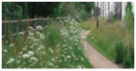

**Draft City Plan Part Two - Community Stakeholder Event**

The council is carrying out a ten-week period of consultation between 5 July to 13 September 2018.

They have a community stakeholder event on 17th July 2018 5.30pm - 6.45pm The Auditorium, Brighthelm Centre North Road which is open to all but no more than two reps per group. BUT YOU HAVE TO REGISTER by 6th July. email [planningpolicy@brighton-hove.gov.uk/](http://planningpolicy@brighton-hove.gov.uk/)Consultation documents are available here. <https://www.brighton-hove.gov.uk/content/planning/planning-policy/city-plan-part-two>

A message from Brighton & Hove Wildlife Forum: “**This is important**, not least because BHCC has no policy for Biodiversity objectives nor targets, within the City Planning Policy.”



**Have a Field Day**

Saturday 7th July is the designated "Fields In Trust" Have a Field Day so hopefully some of our parks will have taken advantage of this day to register their community event. Look out for them across the city.

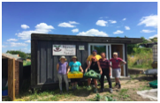

**Nurture Through Nature** is looking for volunteers at its allotment plot in Moulsecoomb to help grow food for the Brighton Unemployed Centre Families Project. They have just built a fabulous community hut and invite you to enjoy it with them! Email [nurturethroughnature@yahoo.co.uk](mailto:nurturethroughnature@yahoo.co.uk) or visit the website for more details.[www.nurturethroughnature.org](http://www.nurturethroughnature.org) Fridays, 10.30am-3.30pm, Plot 36A, Moulsecoomb Estate Allotments, Natal Road, Brighton, BN2 4BN.



**Plants for Bees**A summer workshop - Determining the most attractive plants for bees and other flowers - is being offered by the University of Sussex School of Life Sciences. It will take place on Saturday, 28 July from 11.15 to 3pm. It will combine lectures and hands-on activities. You can book at: <https://alumni.sussex.ac.uk/lasi-workshops-2018>

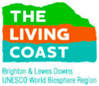

**Growing our Living City**

The Living Coast Biosphere programme and B & H City Council together with Community21 are developing the vision that in 2030 Brighton & Hove will be a Living City, having maintained the sustainability of our natural environment despite the challenges of an increasing population, more urban development and growing climate change impacts. A conference on July 4th will be attended by BHGSF who will report back.

**Connect with the UNESCO World Biosphere Region**

For everything to connect people with nature. “Grasslands are the place to go in high summer to appreciate The Living Coast’s nature at its most exuberant, from chalk downland in the countryside right down to the fringes of parks and road verges in our city and towns” Read more .

<https://www.thelivingcoast.org.uk/news/nature-now-july-2018>



There is a constituting meeting taking place on **Thursday 12th July at 19:00 for a 19:30 start** in **The Learning Resource Centre, Hollingdean Depot, Upper Hollingdean Road, Brighton** to appoint officers and committee members. They currently have 50 trained volunteers and Ranger Garry Meyer invites all to attend. Refreshments will be provided. email:[garry.meyer@brighton-hove.gov.uk](mailto:garry.meyer@brighton-hove.gov.uk)



**Campaign for the Protection of Rural England,**

BHGSF will be attending an informal gathering on 5th July in Brighton. CPRE are working on a strategy for getting more trees planted and replacing those that have been lost.

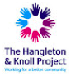

**Hangleton & Knoll project**

Thank you to Jo Martindale who offered four places for their Emergency First Aid course, taking place 14th September - four of our groups members are attending. We will be sending a survey to find out what our membership requirements are regarding further courses which we will undertake to set up.

**Brighton & Hove Food Partnership**

Thank you to Jess Crocker and Helen-Starr-Keddle for information and contacts to help us work towards designing a course for a Leadership/Health and Safety.

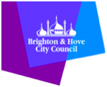

**Active for Life programme of Healthwalks and community activity sessions**

<https://www.brighton-hove.gov.uk/content/leisure-and-libraries/sport-and-activity/healthwalks-programme>

     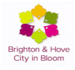

We will be holding a celebratory event to include all city entries to S&SEIB and Brighton & Hove City in Bloom on 15th October at Waterfront Jury’s Inn Hotel hosted by Simon Fanshawe OBE writer and broadcaster. Further details to follow.



**Volunteer at Apple Day 2018**

The event draws over 7000 people to Stanmer Park to enjoy orchard tours, apple juicing, entertainments, stalls, and lots of food and drink, including their own Stanmer Scrump.The link to volunteer on the 23rd September is here <https://connect.brightonpermaculture.org.uk/civicrm/event/register?reset=1&id=1529>

**Local statistics – with thanks to Ranger Chantelle Hoppe**.

·       Public Rights of Way and cycle routes form **7%** of the city’s transports infrastructure.

·       The Public Rights of Way (PRoW) network for Brighton & Hove is **159km** in total length, comprising **54%** footpaths, **40%** bridleways, **4%** restricted byways and **2%** byways.

·       There is **40.1km** of Permissive Path network

·       There is **40km** of cycle routes

·       The Council owns **4,045** hectares of Downland Estat, nost of which is farmland surrounding the city.

·       More than  one third of this land is classified as Open Access **(1,441ha)**

·       **40%** of the land area of Brighton & Hove is within the **South Downs National Park**

**Website -**[**http://bhgreenspaceforum.org.uk**](http://bhgreenspaceforum.org.uk)

**Twitter - @bhgsforum**

**Facebook -**[**https://www.facebook.com/bhgsforum/**](https://www.facebook.com/bhgsforum/)